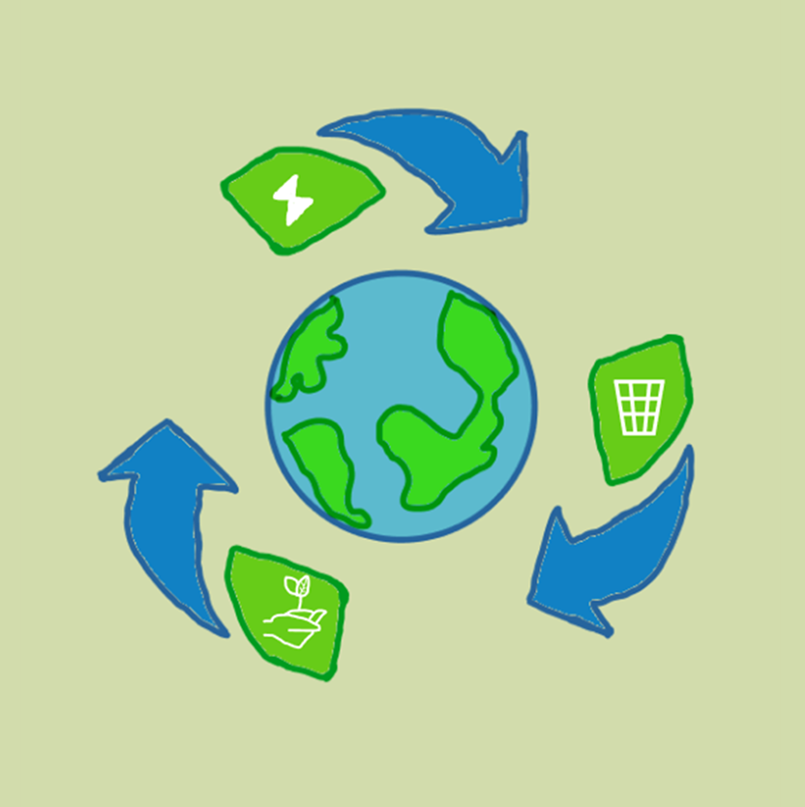

**BioBrain**

**Test plan**

**Contents**

Contents

**1.INTRODUCTION 2**

**2.ENTRY AND EXIT REQUIREMENTS 2**

**3.PROJECT GOALS 2**

**4.TASKS 3**

**5.TESTING 3**

**6.TESTING PROCESS 3**

# 1.Introduction

#### Our game "Bulls and Cows" is a single player game that helps you improve your logical thinking and skills.

# 2.Entry and Exit requirements

**Entry**

* **Access to the game is provided.**
* **The first tests begin.**

**Exit**

* **Most of the tests are successful.**
* **There are no errors preventing the program from working.**

3.Project goals

**We aimed to organize ourselves well as a team and create a working program that people could use as a form of entertainment that also helps improving their thinking.**

# 4.Tasks

**The tasks that must be done to ensure our success are:**

* **To test the most important elements.**
* **Create multiple test cases.**
* **To prepare test and bug documentation.**

# 5.Testing

**Manual testing**

* **Menu options.**
* **Checking that error messages are displayed.**
* **Checking that the correct values are accepted by the code.**
* **Function testing.**

# 6.Testing process

**Test results**

* **Excel table**
* **Test plan**

**Resources**

* **Excel for test management.**
* **Word for Test plan.**
* **GitHub for reporting issues.**